This app is based on my “hello-prisma” basic prisma app <https://github.com/CHDPrismaApps/hello-prisma>

* Copy “hello-prisma” from my GitHub to here.

<https://github.com/CHDPrismaApps/hello-prisma>

The prisma basic app can also be found in my sub-folder: hello-prisma.

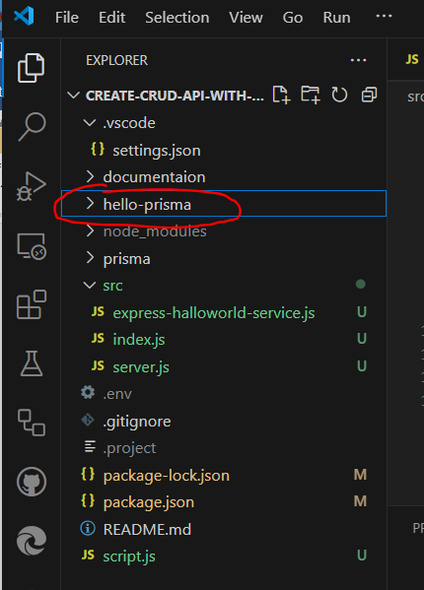

Please read the following 3 documents of hello-prisma first to understand where the codes come from.

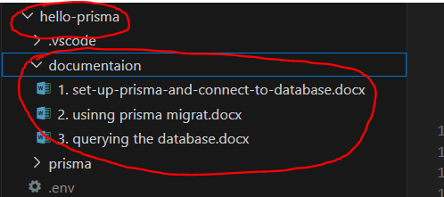

* Refactoring

Rename 🡪 index.js to script.js

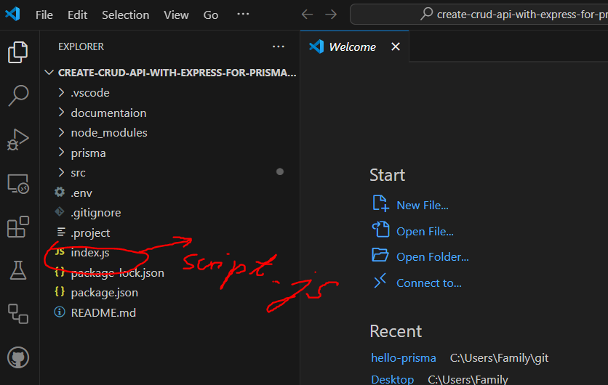

C:\Users\Family\git\hello-prisma> node script.js

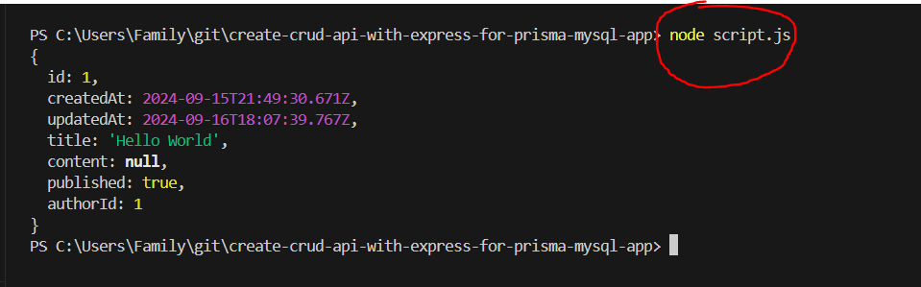

RUN… 🡪 It works – ok

Create a src folder and add three files:

- express-halloworld-service.js  
- index.js  
- server.js

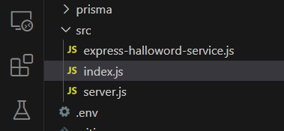

* To create Express Server and Endpoints.

We need first to install express (<https://expressjs.com/>).

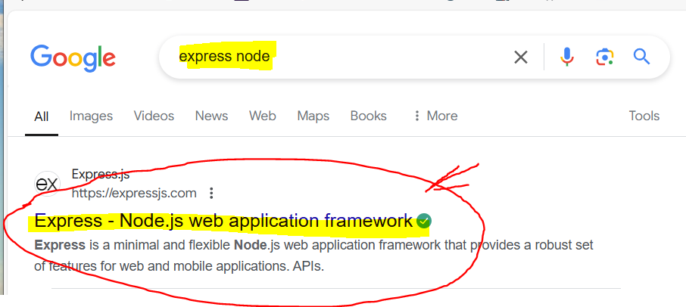

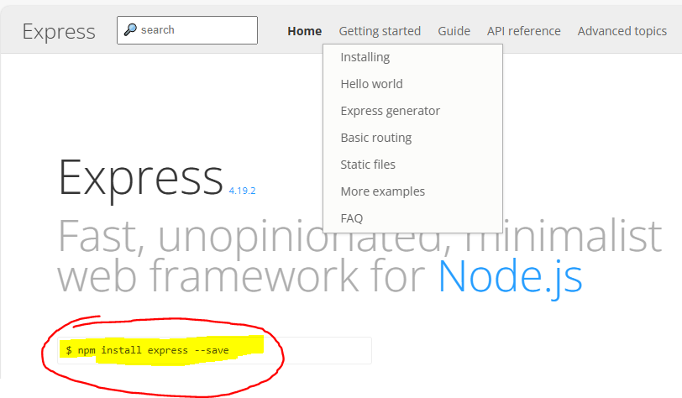

npm install express –save

* Install express

C:\Users\Family\git\create-crud-api-with-express-for-prisma-mysql-app> npm install express –save

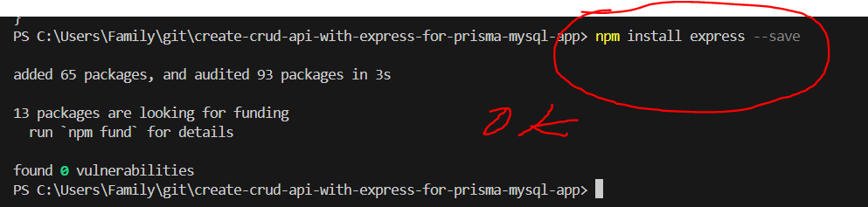

* express was installed.

Edit testcase to express-halloworld-service.js.

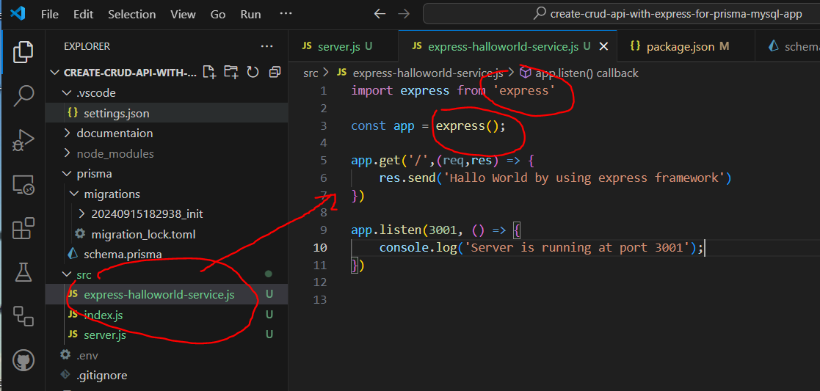

express-halloworld-service.js

import express from 'express'

const app = express();

app.get('/',(req,res) => {

    res.send('Hallo World by using express framework: https://expressjs.com/')

})

app.listen(3001, () => {

    console.log('Server is running at port 3001');

})

* RUN…



C:\Users\Family\git\create-crud-api-with-express-for-prisma-mysql-app>   
node ./express-halloworld-service.js

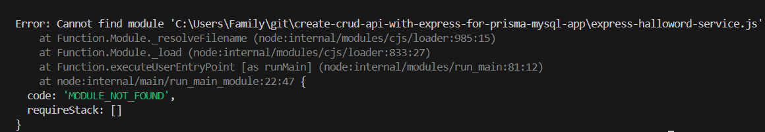

Got ERROR. Install the following dependencies.

npm install --save @types/node  
npm install --save @types/express

C:\Users\Family\git\create-crud-api-with-express-for-prisma-mysql-app> npm install --save @types/node

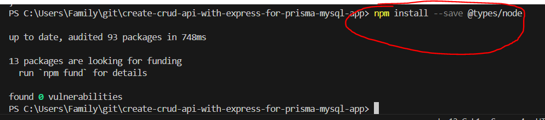  
🡪 Installed OK

C:\Users\Family\git\create-crud-api-with-express-for-prisma-mysql-app> npm install --save @types/express

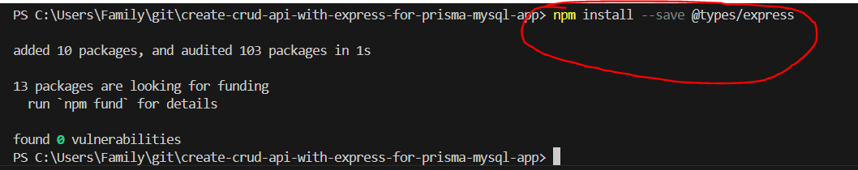

* Installed OK
* RUN…

C:\Users\Family\git\create-crud-api-with-express-for-prisma-mysql-app> node ./express-halloworld-service.js

Got ERROR.

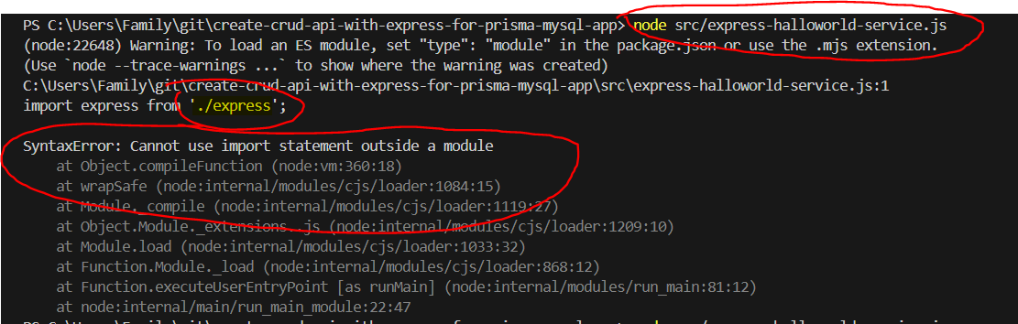

SyntaxError: Cannot use import statement outside a module

at Object.compileFunction (node:vm:360:18)

at wrapSafe (node:internal/modules/cjs/loader:1084:15)

at Module._compile (node:internal/modules/cjs/loader:1119:27)

at Object.Module._extensions..js (node:internal/modules/cjs/loader:1209:10)

at Module.load (node:internal/modules/cjs/loader:1033:32)

at Function.Module._load (node:internal/modules/cjs/loader:868:12)

at Function.executeUserEntryPoint [as runMain] (node:internal/modules/run_main:81:12)

at node:internal/main/run_main_module:22:47

On package.json 🡪 add “type”: “module”

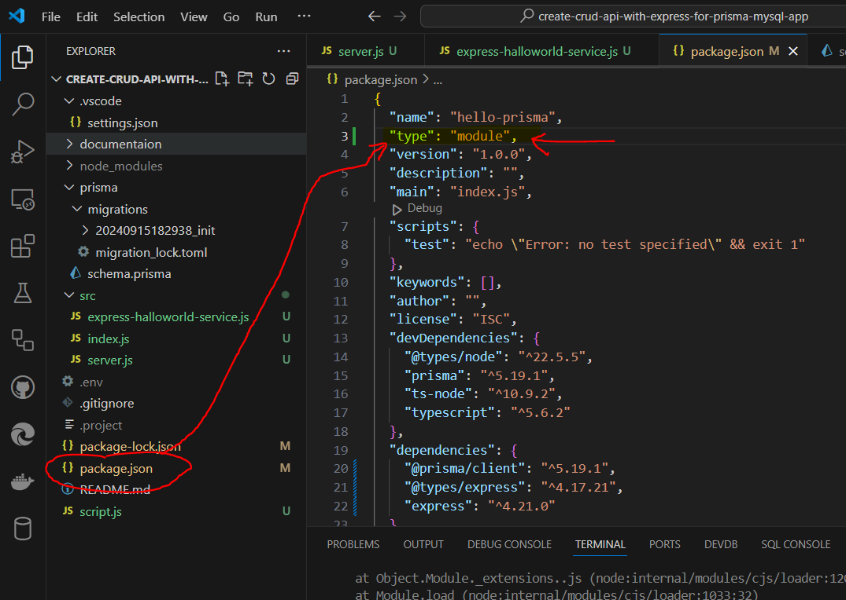

* RUN…

C:\Users\Family\git\create-crud-api-with-express-for-prisma-mysql-app> node src/express-halloworld-service.js

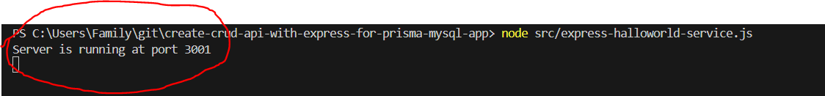

* Server is running at port 3001

Review the code:  res.send('Hallo World by using express framework')

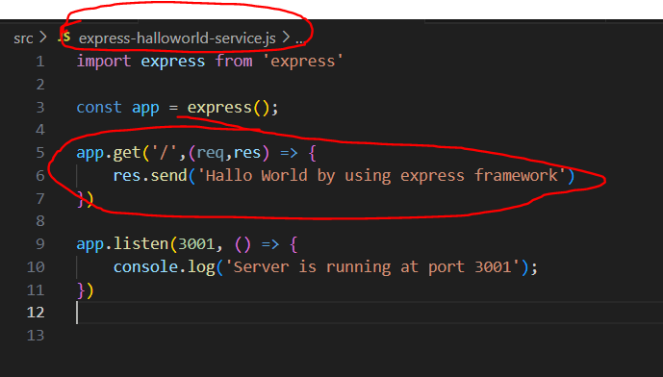

Open browser and type [localhost:3001](http://localhost:3001/)

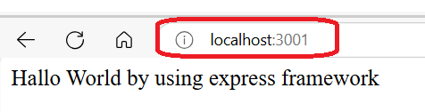

* Successful. OK 😊

Extensions 🡪 Install http client by using Thunder Client 🡪 Rest API Client for VS Code

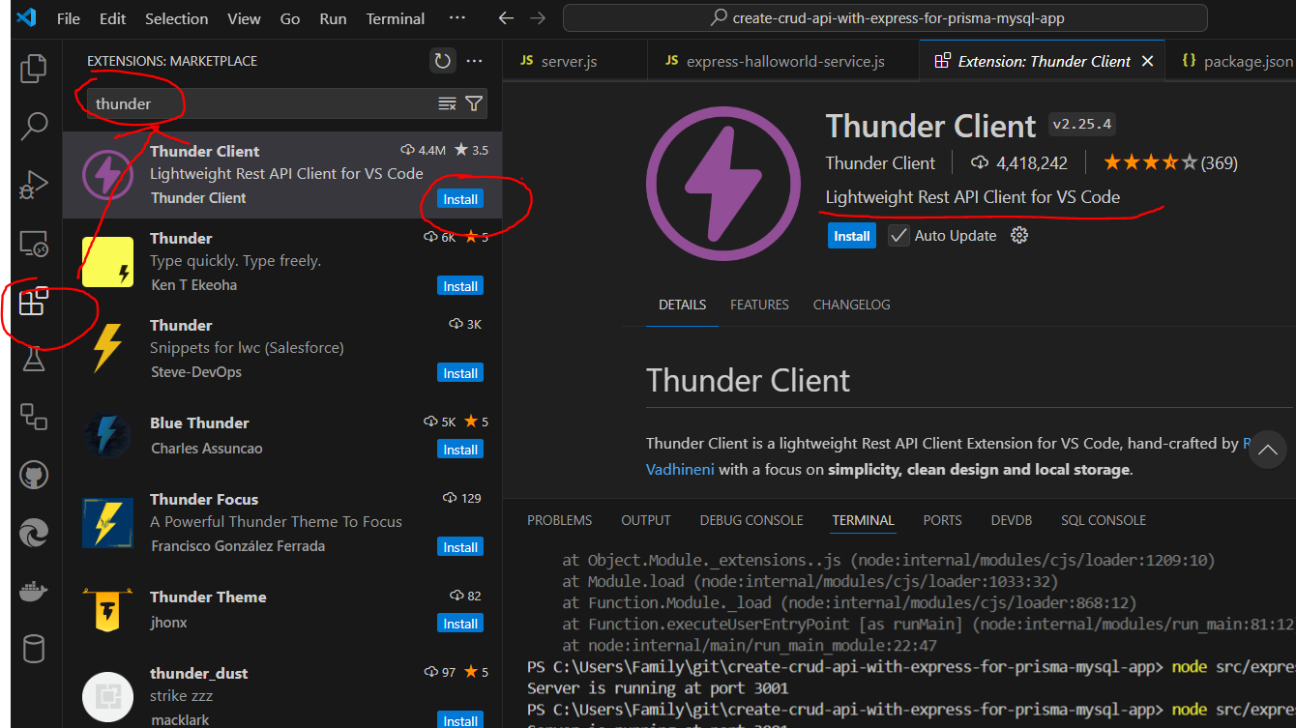

Thunder Client was installed. 🡪 OK

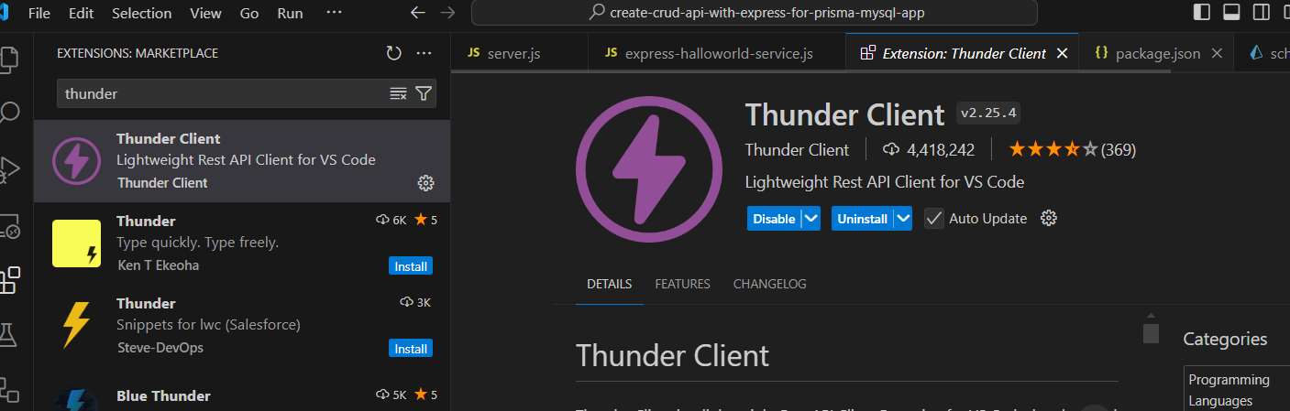

Click 🡪 Thunder Client

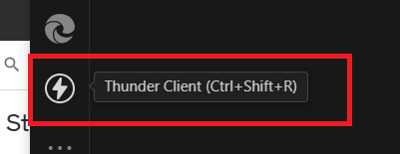

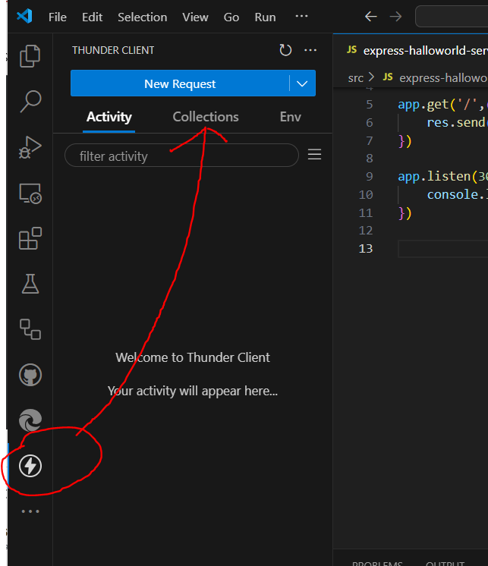

We got the defaut GET request as below:

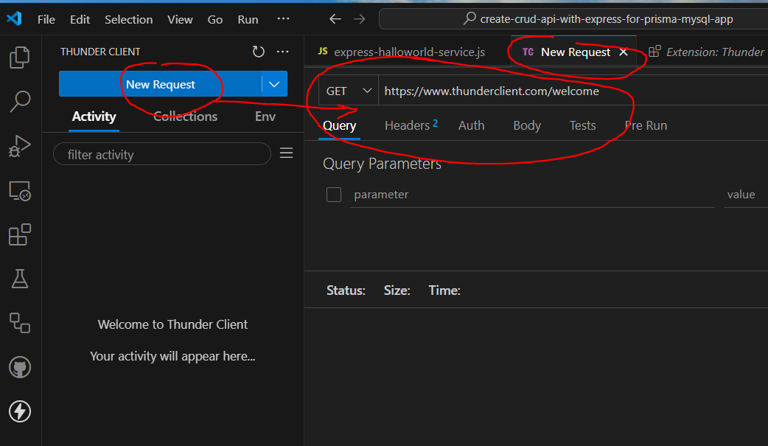

* RUN…

C:\Users\Family\git\create-crud-api-with-express-for-prisma-mysql-app> node ./express-halloworld-service.js



Change the GET request to localhost:3001 and click Send button 🡪 Response Status = 200 OK 🡪 The result is exactly what we want: “Hallo World by using express framework”

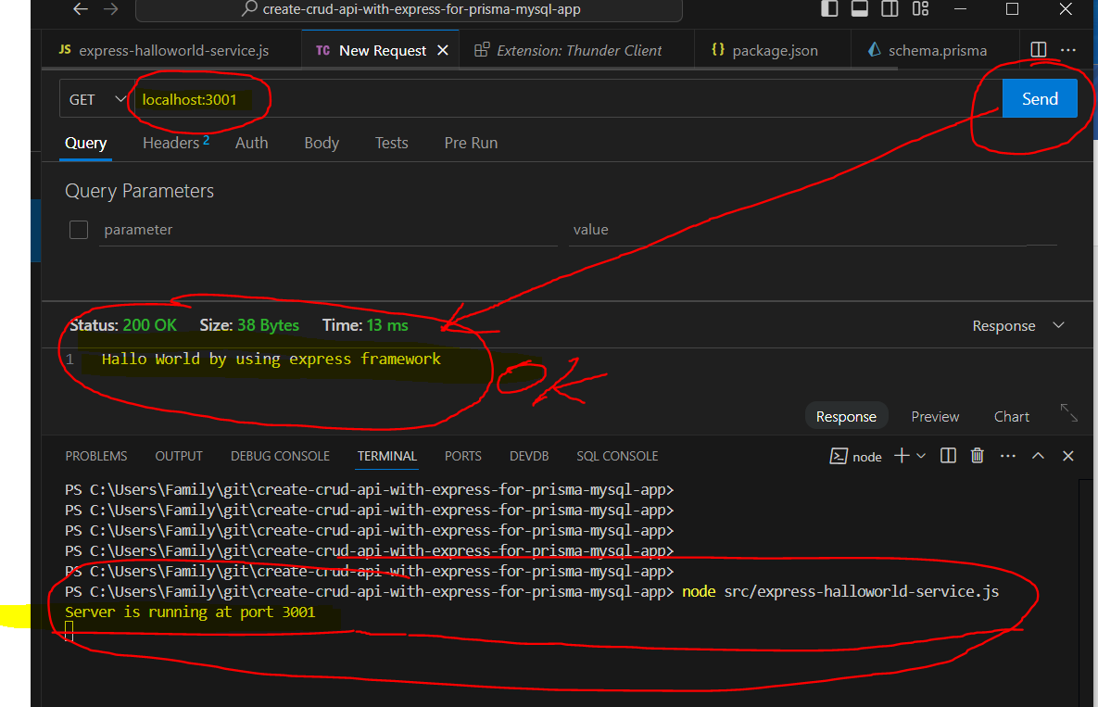

Rest API Client | http Client 🡪 Successful 😊